**Attributes of Quadrilaterals**

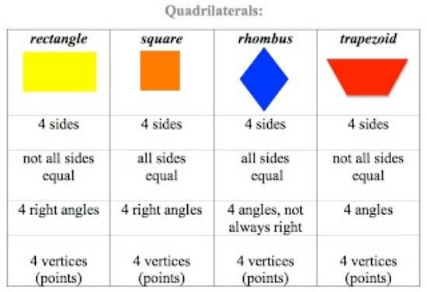

**Some Quadrilaterals are also Parallelograms**

